

Life Skills LFS106
Mobile Phone Tricks

Mobile Phone Tricks and help

SOME THINGS YOU PROBABLY NEVER KNEW YOUR MOBILE PHONE COULD DO !!!

Emergency number
The Emergency Number worldwide for all Mobile Phones
Is 112. If you find yourself out of the coverage area of your
Mobile network and there is an emergency, dial 112
Or (iphone) alternatively if you press the sleep/awake button rapidly 5 times this will activate emergency call.

And your mobile will search any existing network in your area to establish the emergency

Number for you, and interestingly this number 112 can be dialled even
If the keypad is locked, this works on all phones worldwide and is free. It is the equivalent of 000.

Have you locked your keys in the car?
Does your car have remote keyless entry? This may come in handy someday. Good Reason to own a cell phone:
If you lock your keys in the car and the spare keys are at home, call
Someone at home on their mobile phone from your cell phone.

Hold your cell phone about a foot from
Your car door and have the person at your home press the unlock
Button, holding it near the mobile phone on their end.
Your car will probably unlock. Saves someone from having to drive your keys to you. Distance is no object. You could be thousands of miles away,
And if you can reach someone who has the other 'remote' for your car, you can possibly unlock the doors (or the trunk).

Editor's Note: I didn’t believe this when I heard about it! I rang my daughter in Sydney from Perth when we went on holiday. She had the spare car key. We tried it out and it unlocked our car over a mobile phone!'

Hidden Battery Power
To activate, press the keys *3370# (remember the asterisk). Do this when the phone is almost dead.

Your mobile will restart in a special way with this new reserve and the instrument will show a 50%
Increase in battery life. This reserve will get re charged when you charge your mobile next time.

This secret is in the fine print in most phone manuals. Most people however skip this information without realising.

How to disable a STOLEN mobile phone?
To check your Mobile phone's serial
Number, key in the following digits on your phone: * # 0 6 #

Ensure you put an asterisk BEFORE the #06# sequence.

A 15 digit code will appear on the screen. This number is unique to
Your handset. Write it down and keep it somewhere safe. If your
Phone ever gets stolen, you can phone your service provider and give them
This code. They will then be able to block your handset so even if

The thief changes the SIM card, your phone will be totally useless.
You probably won't get your phone back,
But at least you know that whoever stole it can't use/sell it either. If
Everybody done this, there would be no point in people
Stealing mobile phones.

This secret is also in the fine print of most mobile phone manuals. It was created for the very purpose of trying to prevent phones from being stolen.

Every phone in the world has its own 15 digit IMEI number, which you can find by opening your dialler and typing *#06# with the keypad. It's also visible in Settings > About > Device > Status. If you’ve irretrievably lost or had your phone stolen, you can contact your phone company to block your device, simply by quoting your unique number. If everyone did this, phone theft would have virtually no purpose.

Stop Adverts whilst playing games
Stop Adverts breaking into your game, Switch your phone to Airplane mode and will block all adverts, however you will not make or receive calls so only use this when playing games

ATM PIN Number Reversal - Good to Know !!
If you should ever be forced by a robber to withdraw money from an ATM Machine, you can notify the police by entering your PIN # in
Reverse.

For example, if your pin number is 1234, then you would put
In 4321. The ATM system recognizes that your PIN number is backwards

From the ATM card you placed in the machine. The machine will still
Give you the money you requested, but unknown to the robber, the
Police will be immediately dispatched to the location.

All ATM’s carry this emergency sequencer by law.

This information was recently broadcast on by Crime Stoppers
However it is seldom used because people just don't know about it.

All Nokia phones have a short code that you can type in to bring up information on the phone. This is probably the quickest and easiest method of checking your model number. From the main menu key in *#0000#. This will then show you your model number, the version of software running on the phone and a few other bits of info that you don’t need to worry about. The model of the handset will either appear in full (like the N95 shown below) or with the letter N before the model number (as shown on the Nokia 1208 below). Each handset is configured slightly differently, so how it appears on your phone may be slightly different to how its shown here. To go back to the main screen from here, just press ‘end call’ button.

Mobile PHONE Codes
Emergency = 211
Hidden Battery Power = *3370#
Serial number phone: = * # 0 6 #
Nokia Info = *#0000#
Hide your number for outgoing calls = *#31#
For just one call to hide number type = #31#
Nokia Info =*#0000#.

Passwords
Android use the app; WiFi Show to see all the passwords used


Setting Text Replies
iPhones
Settings – Phone – Respond with text = Type your message
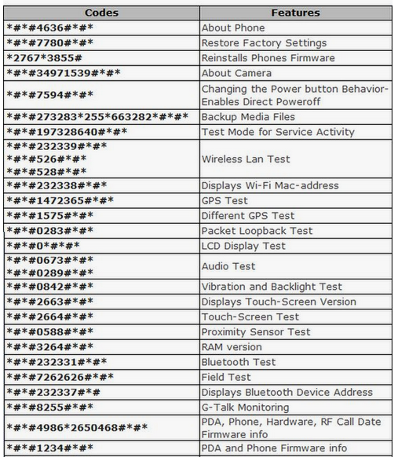
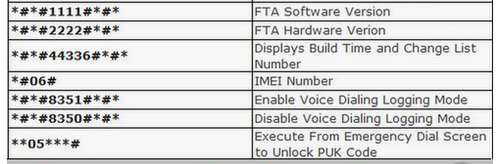

Android Guest Mode
Tap the Icon in the quick setting guide then select Guest (protects your personal data)
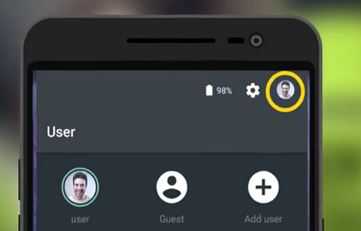

Audio Timer – Turns off Phone after a set time
iOS users only

Select Timer and select timer length then select When Timer Ends and select Stop Playing.

Take Photos whilst shooting Videos
iOS users only iPhone 5 on

Whilst recording tap the camera button and you will take a photo and keep recording.

Share Content Immediately
Android
Tap the Share icon, choose Android Beam and the put the two devise back to back. Share many files.

Keyboard & Mouse
Android
Attach a Keyboard or Mouse using the USB cable

Screen Lock Password
Screen Lock Time Password app click on the clock and enter the numbers shown at that time, your password changes all the time.
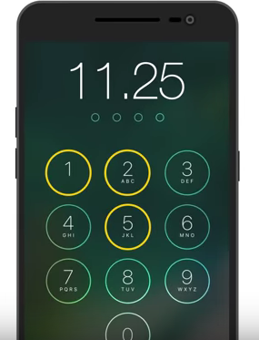

Phone as a listening Device
If you want to turn your phone into a spying device or a baby monitor, then you’re in luck. After enabling the Auto-Answer function, muting the microphone, speaker, ringtone, and vibration, simply put your cell phone in your chosen location, then remove yourself to another place and call the handset (using another device or phone). It will answer automatically without making any sound! And you'll be able to hear everything.

Extending the life of your phone
The power jack at the foot of your phone collects all kinds of dust and dirt through its life, and this is one of the main causes of the device dying. Most of us think nothing of this, but if you actually clean it occasionally you’ll be able to substantially extend the phone’s lifespan, and get more value for money.
Blow into the power jack or insert a syringe full of air into the power jack and inject the air. This will help you clear away the dust.

Silence your ringing phone
1. You can silence your ringing phone speedily by pressing any key on its side. (It’s still ringing — you can answer it or let it go to voicemail — but at least you’ve quieted it.) Remember this when you’re at the theatre, a concert, or in church.

2. There are several ways you can improve your cell phone’s reception: Use your phone near a window if you are inside a building, as walls weaken signals; move away from all electronic equipment, including TVs; stay away from large objects, especially if they contain metal; and move to a higher location if possible.

3. Nothing uses up your phone’s battery like searching for a signal. Turn your phone off when it is out of cell phone signal range.

4. Before traveling overseas, call your phone company to buy a special temporary overseas plan. Many people rack up bills of up to $5,000 while on holiday just because of international Internet fees. If you can’t get an affordable roaming plan, try buying a cheap phone abroad to use with a local SIM card.

5. If you have an iPhone and want to enlarge the screen for ease in reading tiny type, double tap the screen with three fingers. Then pan around by dragging with three fingers. Turn this feature on by tapping Settings, then General, then Accessibility. Double-tap with three fingers to restore the screen magnification.

6. Make sure that you synch all of your contacts and data with your computer. If you have an iPhone this just requires plugging your phone into your computer. It all happens automatically. Then if your phone is lost, you still have all of your information.

